**1 - Create a Spring Web Project using Maven**

**Folder structure**

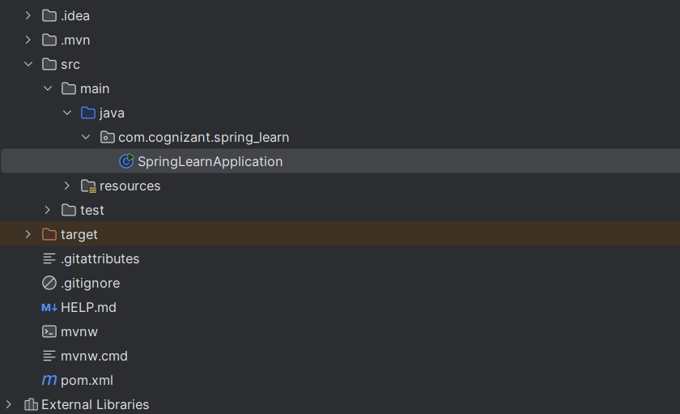

**OUTPUT**

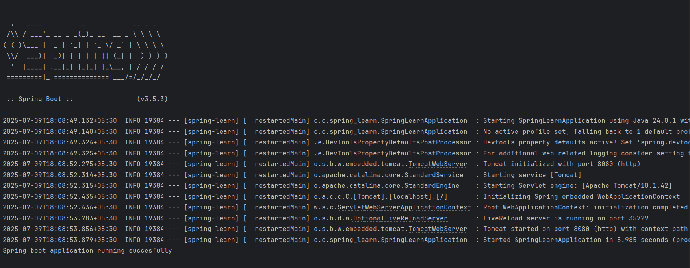

**2 - Spring Core – Load SimpleDateFormat from Spring Configuration XML :**

**SpringLearnApplication.java**

package com.cognizant.spring_learn;  
  
import org.springframework.context.ApplicationContext;  
import org.springframework.context.support.ClassPathXmlApplicationContext;  
  
import java.text.ParseException;  
import java.text.SimpleDateFormat;  
import java.util.Date;  
  
public class SpringLearnApplication {  
  
 public static void main(String[] args) {  
 *displayDate*(); // Call the method to test  
 }  
  
 public static void displayDate() {  
 ApplicationContext context = new ClassPathXmlApplicationContext("date-format.xml");  
  
 SimpleDateFormat format = context.getBean("dateFormat", SimpleDateFormat.class);  
 try {  
 Date date = format.parse("31/12/2018");  
 System.*out*.println("Parsed Date: " + date);  
 } catch (ParseException e) {  
 System.*out*.println("Invalid date format!");  
 e.printStackTrace();  
 }  
 }  
}

**Date-format.xml**

<?xml version="1.0" encoding="UTF-8"?>

<beans xmlns="http://www.springframework.org/schema/beans"

xmlns:xsi="http://www.w3.org/2001/XMLSchema-instance"

xsi:schemaLocation="http://www.springframework.org/schema/beans

https://www.springframework.org/schema/beans/spring-beans.xsd">

<bean id="dateFormat" class="java.text.SimpleDateFormat">

<constructor-arg value="dd/MM/yyyy"/>

</bean>

</beans>

**OUTPUT**

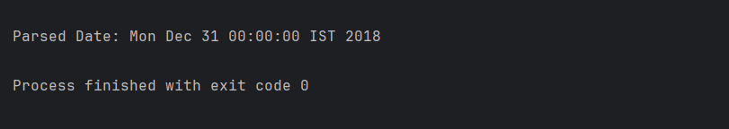

**3 . Spring Core - Incorporate Logging**

**SpringLearnApplication.java**

package com.cognizant.spring_learn;  
import org.slf4j.Logger;  
import org.slf4j.LoggerFactory;  
import org.springframework.context.ApplicationContext;  
import org.springframework.context.support.ClassPathXmlApplicationContext;  
import java.text.ParseException;  
import java.text.SimpleDateFormat;  
import java.util.Date;  
public class SpringLearnApplication {  
 private static final Logger *LOGGER* = LoggerFactory.*getLogger*(SpringLearnApplication.class);  
 public static void main(String[] args) {  
 *LOGGER*.info("Inside main()");  
 *displayDate*();  
 }  
 public static void displayDate() {  
 *LOGGER*.info("START");  
 ApplicationContext context = new ClassPathXmlApplicationContext("date-format.xml");  
 SimpleDateFormat format = context.getBean("dateFormat", SimpleDateFormat.class);  
 try {  
 Date date = format.parse("31/12/2018");  
 *LOGGER*.debug("Parsed Date: {}", date.toString());  
 *LOGGER*.info("Parsed Date (forcing debug as info): {}", date.toString());  
 } catch (ParseException e) {  
 *LOGGER*.error("Error parsing date", e);  
 }  
 *LOGGER*.info("END");  
 }  
}

**Application.properties**

spring.application.name=spring-learn  
logging.level.org.springframework=info  
logging.level.com.cognizant.spring_learn=debug  
logging.pattern.console=%d{yyMMdd}|%d{HH:mm:ss.SSS}|%-20.20thread|%5p|%-25.25logger{25}|%25M|%m%n  
LOGGER.info("Parsed Date (forcing debug as info): {}", date.toString());

**OUTPUT**

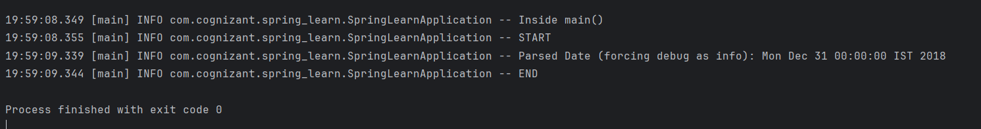

**5 - Spring Core – Load Country from Spring Configuration XML**

**Country.java**

package com.cognizant.spring_learn;  
import org.slf4j.Logger;  
import org.slf4j.LoggerFactory;  
public class Country {  
 private static final Logger *LOGGER* = LoggerFactory.*getLogger*(Country.class);  
 private String code;  
 private String name;  
 public Country() {  
 *LOGGER*.debug("Inside Country Constructor.");  
 }  
 public String getCode() {  
 *LOGGER*.debug("Inside getCode()");  
 return code;  
 }  
 public void setCode(String code) {  
 *LOGGER*.debug("Inside setCode()");  
 this.code = code;  
 }  
 public String getName() {  
 *LOGGER*.debug("Inside getName()");  
 return name;  
 }  
 public void setName(String name) {  
 *LOGGER*.debug("Inside setName()");  
 this.name = name;  
 }  
 @Override  
 public String toString() {  
 return "Country [code=" + code + ", name=" + name + "]";  
 }  
}

**SpringLearnApplication.java**

package com.cognizant.spring_learn;

import org.slf4j.Logger;

import org.slf4j.LoggerFactory;

import org.springframework.context.ApplicationContext;

import org.springframework.context.support.ClassPathXmlApplicationContext;

import java.text.ParseException;

import java.text.SimpleDateFormat;

import java.util.Date;

public class SpringLearnApplication {

private static final Logger LOGGER = LoggerFactory.getLogger(SpringLearnApplication.class);

public static void main(String[] args) {

LOGGER.info("Inside main()");

displayDate();

displayCountry();

}

public static void displayDate() {

LOGGER.info("START");

ApplicationContext context = new ClassPathXmlApplicationContext("date-format.xml");

SimpleDateFormat format = context.getBean("dateFormat", SimpleDateFormat.class);

try {

Date date = format.parse("31/12/2018");

LOGGER.info("Parsed Date: {}", date.toString());

} catch (ParseException e) {

LOGGER.error("Error parsing date", e);

}

LOGGER.info("END");

}

public static void displayCountry() {

LOGGER.info("START");

ApplicationContext context = new ClassPathXmlApplicationContext("country.xml");

Country country1 = context.getBean("country", Country.class);

Country country2 = context.getBean("country", Country.class);

LOGGER.info("Country1 : {}", country1);

LOGGER.info("Country2 : {}", country2);

LOGGER.info("Are both country beans the same? {}", country1 == country2);

LOGGER.info("END");

}

}

**Countries.xml**

<?xml version="1.0" encoding="UTF-8"?>  
<beans xmlns="http://www.springframework.org/schema/beans"  
 xmlns:xsi="http://www.w3.org/2001/XMLSchema-instance"  
 xsi:schemaLocation="http://www.springframework.org/schema/beans  
 https://www.springframework.org/schema/beans/spring-beans.xsd">  
 <bean id="country" class="com.cognizant.spring_learn.Country">  
 <property name="code" value="IN" />  
 <property name="name" value="India" />  
 </bean>  
</beans>

**OUTPUT**

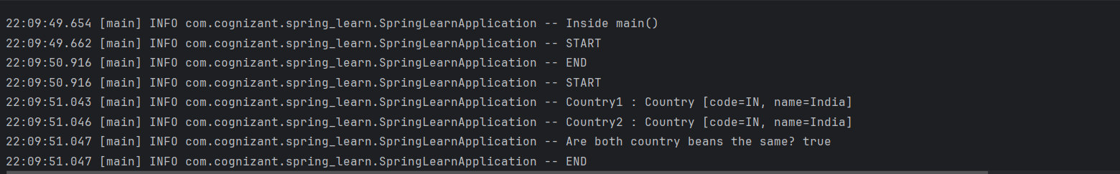

**6-Spring Core – Load list of countries from Spring Configuration XML**

**SpringLearnApplication.java**

package com.cognizant.spring_learn;

import org.slf4j.Logger;

import org.slf4j.LoggerFactory;

import org.springframework.context.ApplicationContext;

import org.springframework.context.support.ClassPathXmlApplicationContext;

import java.text.ParseException;

import java.text.SimpleDateFormat;

import java.util.ArrayList;

import java.util.Date;

import java.util.List;

public class SpringLearnApplication {

private static final Logger LOGGER = LoggerFactory.getLogger(SpringLearnApplication.class);

public static void main(String[] args) {

LOGGER.info("Inside main()");

displayDate();

displayCountry();

displayCountries();

}

public static void displayDate() {

LOGGER.info("START");

ApplicationContext context = new ClassPathXmlApplicationContext("date-format.xml");

SimpleDateFormat format = context.getBean("dateFormat", SimpleDateFormat.class);

try {

Date date = format.parse("31/12/2018");

LOGGER.info("Parsed Date: {}", date.toString());

} catch (ParseException e) {

LOGGER.error("Error parsing date", e);

}

LOGGER.info("END");

}

public static void displayCountry() {

LOGGER.info("START");

ApplicationContext context = new ClassPathXmlApplicationContext("country.xml");

Country country1 = context.getBean("country", Country.class);

Country country2 = context.getBean("country", Country.class);

LOGGER.info("Country1 : {}", country1);

LOGGER.info("Country2 : {}", country2);

LOGGER.info("Are both country beans the same? {}", country1 == country2);

LOGGER.info("END");

}

public static void displayCountries() {

LOGGER.info("START");

ApplicationContext context = new ClassPathXmlApplicationContext("country.xml");

List<Country> countryList = context.getBean("countryList", ArrayList.class);

LOGGER.debug("Country List: {}", countryList);

LOGGER.info("END");

}

}

**Country.java**

package com.cognizant.spring_learn;

import org.slf4j.Logger;

import org.slf4j.LoggerFactory;

public class Country {

private static final Logger LOGGER = LoggerFactory.getLogger(Country.class);

private String code;

private String name;

public Country() {

LOGGER.debug("Inside Country Constructor.");

}

public String getCode() {

LOGGER.debug("Inside getCode()");

return code;

}

public void setCode(String code) {

LOGGER.debug("Inside setCode()");

this.code = code;

}

public String getName() {

LOGGER.debug("Inside getName()");

return name;

}

public void setName(String name) {

LOGGER.debug("Inside setName()");

this.name = name;

}

@Override

public String toString() {

return "Country [code=" + code + ", name=" + name + "]";

}

}

Country.xml

<?xml version="1.0" encoding="UTF-8"?>

<beans xmlns="http://www.springframework.org/schema/beans"

xmlns:xsi="http://www.w3.org/2001/XMLSchema-instance"

xsi:schemaLocation="http://www.springframework.org/schema/beans

https://www.springframework.org/schema/beans/spring-beans.xsd">

<bean id="country" class="com.cognizant.spring_learn.Country" scope="singleton">

<property name="code" value="IN" />

<property name="name" value="India" />

</bean>

<bean id="in" class="com.cognizant.spring_learn.Country">

<property name="code" value="IN" />

<property name="name" value="India" />

</bean>

<bean id="us" class="com.cognizant.spring_learn.Country">

<property name="code" value="US" />

<property name="name" value="United States" />

</bean>

<bean id="de" class="com.cognizant.spring_learn.Country">

<property name="code" value="DE" />

<property name="name" value="Germany" />

</bean>

<bean id="jp" class="com.cognizant.spring_learn.Country">

<property name="code" value="JP" />

<property name="name" value="Japan" />

</bean>

<bean id="countryList" class="java.util.ArrayList">

<constructor-arg>

<list>

<ref bean="in"/>

<ref bean="us"/>

<ref bean="de"/>

<ref bean="jp"/>

</list>

</constructor-arg>

</bean>

</beans>

**OUTPUT**

